MEMORANDUM

Date: July 31, 2026

Re: Mandatory Office Equipment

Effective immediately, all employees will be required to maintain in their workplace the following mandatory office equipment, and shall become familiar with its proper use.

The intent is to relieve stress, promote a friendly work environment and assist employees in generally coping with their co-workers and supervisors.

All employees are to keep with them, two (2) paperclips and two (2) elastic bands. See Figure 1 below. If you do not already have access to this equipment, please get it from the supply cabinet. Keep assembled and ready as shown in Figure 2.
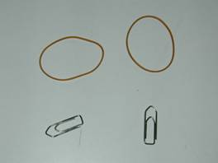
Fig 1: MOE - Paperclips and Elastic Bands.

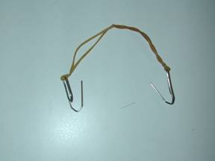

Fig 2: MOE Assembly.

Whenever necessary, i.e. if your supervisor drops off a ton of work on your desk at 4:45 pm on a Friday, place on head as illustrated in Figure 3.
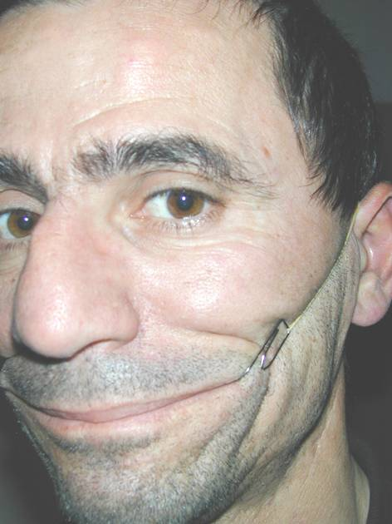

Fig 3: Proper application

We hope that this will help promote a friendlier work environment.

Enjoy your day.

The Management

