1.. My wife and I divorced over religious differences. She thought she was
God and I didn't.
2.. I Work Hard Because Millions On Welfare Depend on Me!
3.. Some people are alive only because it's illegal to kill them.
4.. I used to have a handle on life, but it broke.

5.. Don't take life too seriously; No one gets out alive.
6.. You're just jealous because the voices only talk to me
7.. Beauty is in the eye of the beer holder.
8.. I'm not a complete idiot -- Some parts are just missing.
(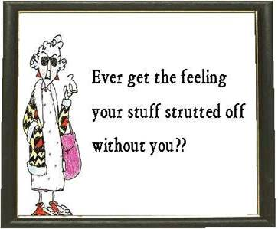
9.. Out of my mind. Back in five minutes.
10. NyQuil, the stuffy, sneezy, why-the-heck-is-the-room-spinning
medicine.
11.. God must love stupid people; He made so many.
12.. The gene pool could use a little chlorine.
13. Consciousness: That annoying time between naps.
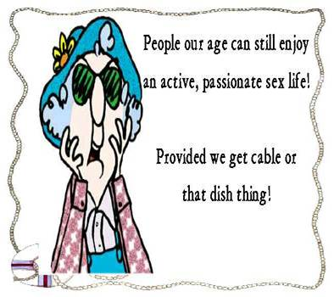
14.. Ever stop to think, and forget to start again?
15.. Being "over the hill" is much better than being under it!
16.. Wrinkled Was Not One of the Things I Wanted to Be When I Grew up.
17.. Procrastinate Now!
18.. I Have a Degree in Liberal Arts; Do You Want Fries With That?
19.. A hangover is the wrath of grapes.
20.. Stupidity is not a handicap. Park elsewhere!
21.. The trouble with life is there's no background music.
22.. The original point and click tool was a Smith and Wesson.

